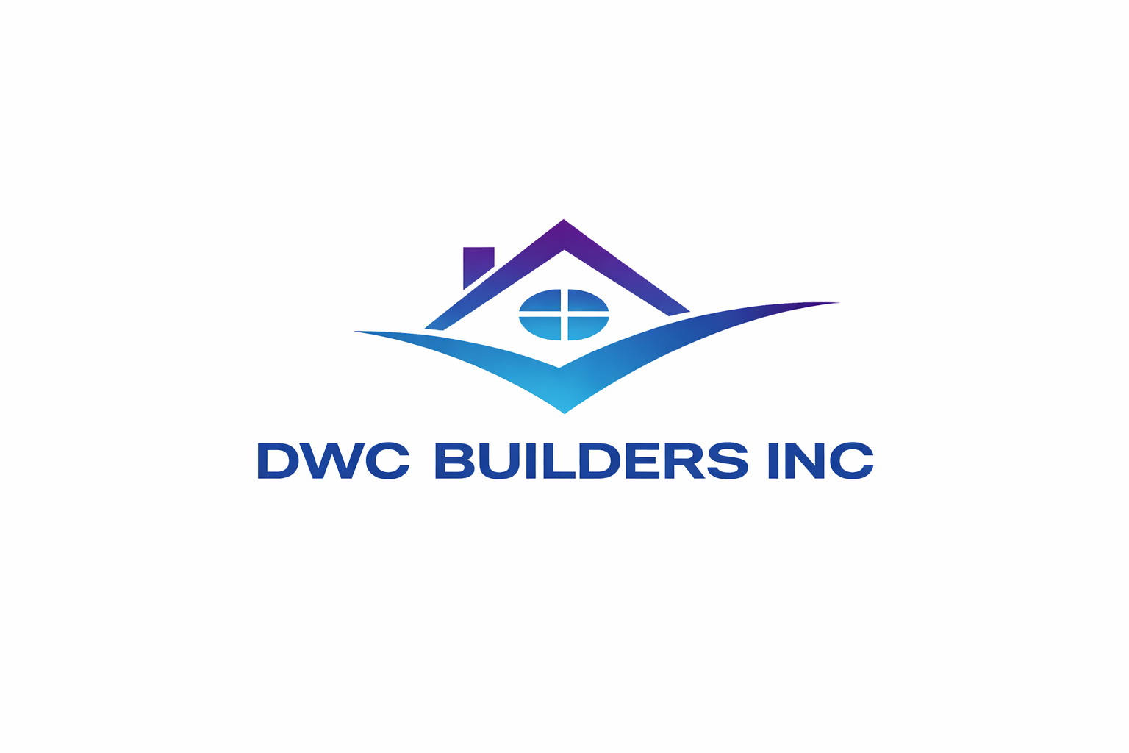
Crafting Your Dream Kitchen/Bath
One Surface at a Time
Your partner in selecting premium kitchen/bath surfaces, you can trust DWC Builders, Inc. to curate the ideal kitchen countertop or bathroom vanity for your lifestyle. It’s important that you review the pros and cons of the countertops/vanities you’re considering, especially when the materials are comparable in price. It’s also important to consider materials that are more likely to resist stains and chips.
Let us help you find a kitchen countertop or vanity that balances style, budget, and durability.

Sizable Samples: Small samples make it hard to visualize what the material will look like in a kitchen/bath. It’s fine to play with online design tools, but look at the materials up close and take home large samples, even if you have to pay for them. If you’re considering stone, go to the stone yard. Color and veining can vary widely even within a slab, so when you find one you love, reserve it.

Watch the Warranty: Whatever countertop material you’re considering, ask about the warranty.

Consider the Sink: A top-mounted sink can be used with any countertop material and is dropped in after the counter is installed. An undermounted sink is placed under the countertop and works best with waterproof countertop materials such as concrete, solid surfacing, stainless steel, stone, or quartz. Some materials, such as solid surfacing and stainless steel, can be used for both the sink and counter, creating a seamless look.
Ways to Save: Look for sales and consider mixing materials, using the more expensive material in prominent areas, such as an island, and the less expensive material on the perimeter. Buying remnants is a possibility for smaller areas, such as an island, pastry slab, or bathroom counter, and you could mix and match remnants for bigger areas. Beveled and bull-nosed edges add style but may boost cost. Rounded edges are safer than squared edges and may not cost extra.
Manage Those Measurements: Have the fabricator take final measurements, making accuracy their responsibility. Insist that the estimate and contract specify the material’s thickness and finish; fees for cutouts for the sink, faucet, and cooktop; and the edge treatment, the backsplash, and the removal of old counters.

Countertops: What’s Your Type? Granite has long reigned as the top countertop choice, but as chameleons go, quartz is impressive. This synthetic stone offers an increasingly realistic look, resembling materials such as marble, granite, and concrete, and is easier to maintain than those materials. Here are the countertop materials to consider:

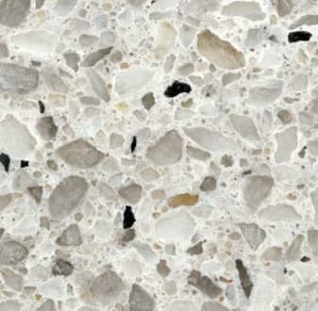 Quartz

Quartz, also known as engineered stone, is a blend of stone chips, resins, and pigments and is ideal for areas that get plenty of use. It comes in vibrant colors and styles that mimic stone. Pros: Quartz survives spills, hot pots, knives, and more with top scores in our tests, and it doesn’t have to be sealed for stain protection. It’s waterproof, so it can be paired with an undermounted sink. Cons: Some patterns appear unnaturally uniform, although manufacturers are trying for a more random look closer to natural stone. Edges and corners can chip, and only a pro can repair them. Rounded edges help.
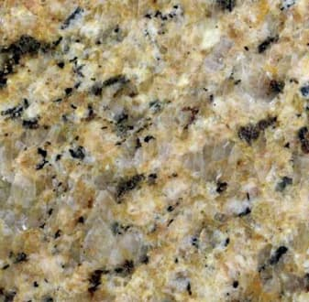

Granite Each slab of this natural material is unique. It remains popular and is a good choice for heavily used areas. It can be used with an undermounted sink. Pros: Like quartz, granite will survive spills, hot pots, knives, and more with top scores. Cons: Edges and corners can chip and you’ll need a pro to repair them, and granite needs periodic sealing for stain protection.
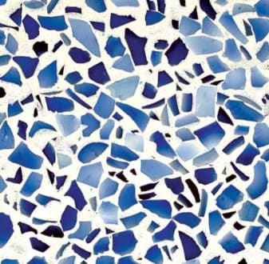 Recycled Glass

Take shards of recycled glass, turn them into a countertop, and the result is an infusion of color and style. Pros: Best for a contemporary look when it’s made with large shards, or it can resemble solid surfacing when the glass is finely ground. It’s resistant to heat, cuts, and scratches. Cons: Susceptible to chips and stains and it can develop thin cracks when heat is applied.

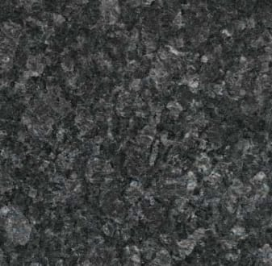 Laminates
Made of layers of paper or fabric with resin over composition wood, laminates come in a variety of patterns and colors. It’s best for areas of heavy use but minimal abuse. Laminates can show seams, but some have decorative edges to hide that. Another option is post-forming, a process using heat to form/bend laminate sheets, making them look seamless. Pros: Laminates excel at resisting stains, impact, and heat, and withstand abrasive pads. They’re inexpensive and easy to clean, and a good choice for a tight budget. Cons: Most laminates have a colored top layer over a dark core, which shows at the edges. Water can seep through seams or between the countertop and backsplash, weakening the material. Laminate is easily scratched and nicked and can’t be repaired. Textured finishes are better than flat finishes at hiding imperfections.

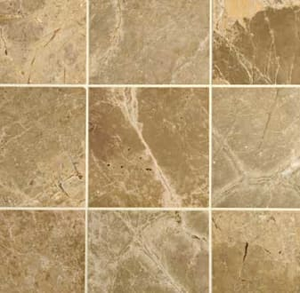
Tile

Ceramic tile comes in a wide selection of colors and patterns. It mixes nicely with other materials and works well on a backsplash or an island top. Pros: Tile is inexpensive and relatively easy to install. It offers excellent heat resistance, so it’s a good choice around stoves. Buying a few extra tiles allows you to repair damage easily, one tile at a time. Cons: The grout is likely to stain even when it’s sealed, although darker grout can help, and tile edges and corners can chip.

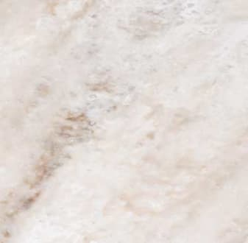 Ultracompact
A new countertop category, Dekton, an ultra-compact, high-performance engineered stone, is a combination of quartz, porcelain, and glass. Pros: It resists damage from heat, stains, chopping, and cutting, and resist abrasion. Cons: In impact tests, pieces of the edges chipped off and cracked into two pieces on samples that were 2 centimeters thick, the manufacturer’s recommended thickness. These tests simulate what could happen if a heavy pot fell from a shelf.

 Solid Surfacing
This material, made of polyester or acrylic resins combined with mineral fillers, imitates concrete, marble, and other types of stone, as well as quartz (an imitation of an imitation). Solid surfacing can be used for counters, sinks, and backsplashes, creating a seamless look. Pros: It’s resistant to heat and impacts, and scratches and small nicks can be buffed out and repaired. The material is waterproof, so it’s a good choice for an undermounted sink. Cons: Solid surfacing scratches and cuts easily.

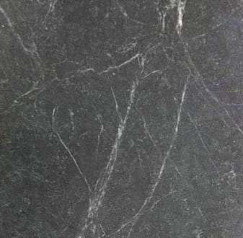

Soapstone
It’s beautiful and not as common as granite. Pros: It’s best for adding the beauty of stone to a low-traffic kitchen. It withstands heat very well, and small scratches can be repaired. Slabs vary, so go to a stone yard to pick the piece you love. Cons: It’s easily sliced, scratched, and nicked. Stain resistance is so-so, and it needs to be periodically finished with mineral oil.
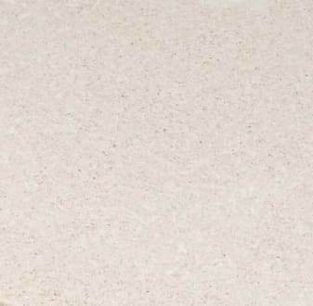

Concrete
Concrete countertops can provide a unique look because this material is typically custom-formed by local fabricators. That said, quality can vary. Pros: Concrete can be tinted and textured, and can include stone chips. Cons: It chips and scratches easily and can develop hairline cracks. Topical sealers can protect against stains but not heat; penetrating sealers can handle heat but not stains.


Stainless Steel
This material allows you to integrate countertops in a kitchen with stainless appliances for a sleek, commercial kitchen look. Stainless can be welded, ground, and buffed to remove seams. Pros: It’s resistant to heat and stains. Cons: Stainless steel dents and scratches easily and shows fingerprints. Drain cleaners and hard water deposit removers can discolor steel.
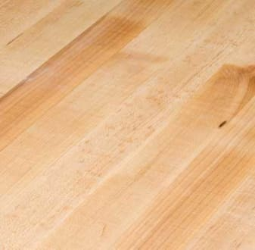

Butcher Block
These countertops add warmth to any kitchen. Maple is common, but you’ll also see other woods, including teak. Pros: This material is useful for food preparation, such as chopping and slicing. It’s relatively easy to install and repair. Cons: Damage from heat, cuts, scrapes, and impacts makes for high maintenance. It has to be treated regularly with mineral oil or beeswax. Varnishing provides stain resistance but no other protection. An oil finish is better at resisting heat, but stains spread and are impossible to remove. Fluctuations in humidity affect wood, making butcher block a poor choice for over a dishwasher or around a sink.

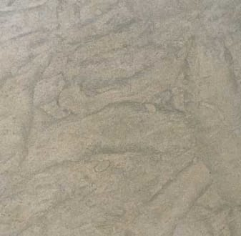

Limestone
Limestone provides a stone look without heavy veining. It’s attractive but impractical, so consider it for low-traffic areas. Pros: Limestone resists heat well. Cons: Scratches and dings. Dropping a 5-pound weight on it will mar the surface of this soft, porous stone, and even a high-quality sealer won’t protect it against stains. In tests, 11 of the 20 substances that were applied left visible stains after they were left on the surface for just 24 hours.

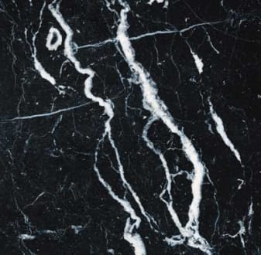

Marble
Beautiful and classic, marble has been used in European kitchens for ages. To some, marble takes on a patina, but others see it as marred. Pros: Small nicks and scratches can be polished out. Cons: Marble chips and scratches easily. It must be sealed periodically to protect it from staining. In tests, most stains that marred unsealed marble were wiped away with water on sealed samples, but hard water deposit removers left a permanent mark, even on sealed stone.

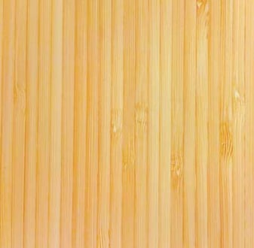

Bamboo
While bamboo may be eco-friendly, it isn’t user-friendly. Pros: Best for show rather than daily use, it’s available in several styles, including a parquet pattern. Cons: It’s easily stained, scorched, sliced, and nicked. Ask if you can use it near a sink because moisture can warp it. Bamboo may darken over time.
We look forward to making your dream kitchen or bath a reality!

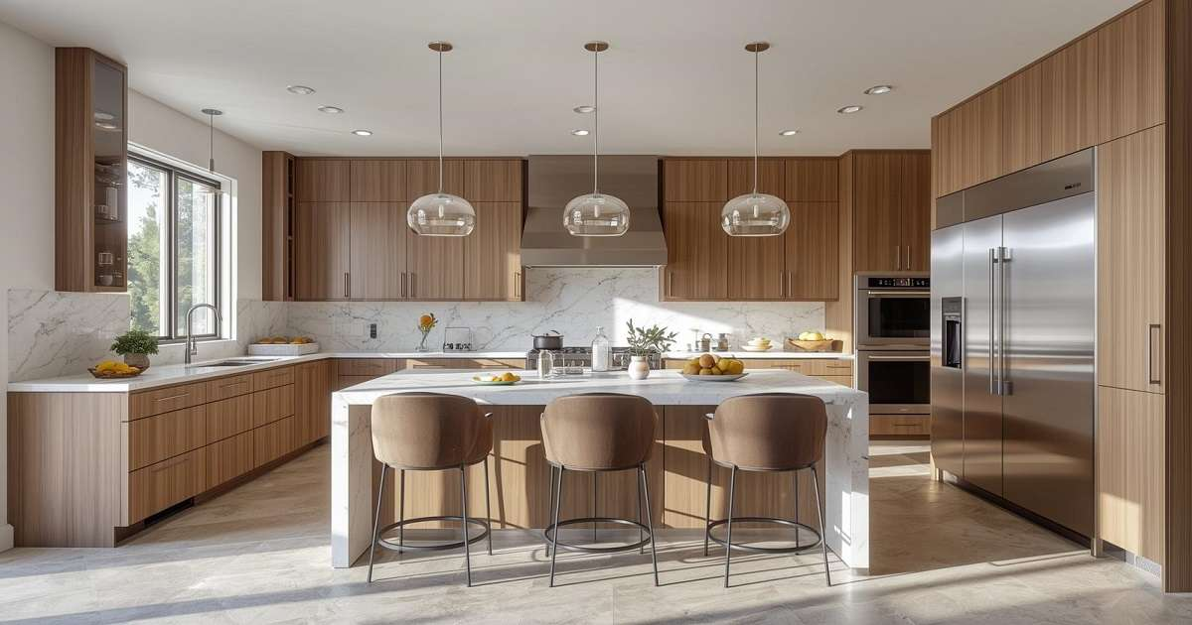
Discover the best materials for your home with
DWC Builders, Inc.

